Introducing Microsoft Foundry
Training Guide — From Azure AI Foundry to the Enterprise Agent Platform
With real-world company use cases and workflow charts

Learning Objectives
After completing this guide, you will be able to:
- Explain what Microsoft Foundry is and how it relates to the Azure AI Foundry / Azure AI Studio names that appear in older tutorials
- Describe the Foundry resource hierarchy: Foundry resource → projects → connected Azure services
- Tell the difference between the Foundry (New) and Foundry (Classic) portal experiences and know when to use each
- Explain what Foundry Agent Service and Foundry IQ add on top of plain model deployment
- Describe how real companies — Heineken, Fujitsu, Gallagher, KPMG, H&R Block, and others — run AI agents on Foundry in production, and recognize the common workflow patterns behind them

1. Why the Name Changed (Again)

1.1 The Naming Timeline
When | Name | What it was
Nov 2023 | Azure AI Studio | First unified portal for building AI apps on Azure
Nov 2024 (Ignite) | Azure AI Foundry | Rebrand + expansion — the name used in most 2025 tutorials and earlier course handouts
Nov 18, 2025 (Ignite) | Microsoft Foundry | Rebrand + platform pivot toward multi-agent applications; formalized in the January 2026 Product Terms

Microsoft's stated reason for dropping “Azure” from the name is to position agents as first-class citizens across the whole Microsoft ecosystem (Microsoft 365, Teams, Copilot), not just an Azure-only tool. Practically: it is the same underlying platform used throughout this course — the portal at ai.azure.com — just renamed and, in the new portal experience, restructured.
Source: Microsoft Learn, “What is Microsoft Foundry?” and Microsoft Ignite 2025 announcements, as reflected in Microsoft's January 2026 Product Terms update.

1.2 What Actually Changed vs. What's Just a Label
Just a rename | A real change underneath
“Azure AI Foundry” → “Microsoft Foundry” in every doc and menu | A new portal experience (“Foundry New”) with a different resource and project model
“Azure AI Services” → “Foundry Tools” | Assistants API is being retired in favor of the Responses API (“Agents v2”)
 | Terminology shift: Threads / Messages / Runs / Assistants → Conversations / Items / Responses / Agent Versions
 | Model catalog expanded past OpenAI to include Anthropic Claude, Grok, Mistral, DeepSeek, Meta Llama, and more

If an older blog post or YouTube tutorial still says “Azure AI Foundry” and shows different menus than the current portal, that is expected — the platform underneath is the same one described in this guide.

2. Architecture: How a Foundry Resource Is Organized

2.1 The Resource Hierarchy
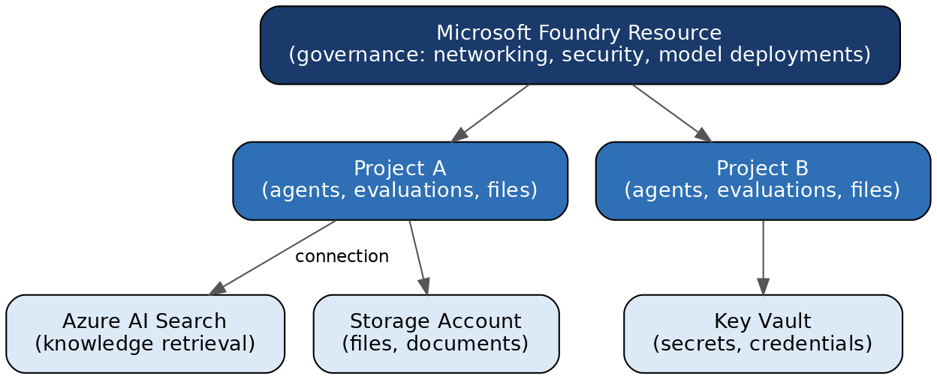
Figure 1 — Foundry resource hierarchy: one governed resource, multiple projects, separately governed connections
This is exactly the shape of the resource used in this course: a Foundry resource (previously called the “Azure OpenAI resource” in the setup guide) containing one or more projects, connected out to an Azure AI Search service for the RAG knowledge base.

2.2 Resource Types Under the Hood
Resource type | Azure resource provider | What it covers
Microsoft Foundry | Microsoft.CognitiveServices/accounts | Agents, evaluations, Azure OpenAI, Speech, Vision, Language, Content Understanding
Foundry project | Microsoft.CognitiveServices/accounts/projects | A sub-resource of the Foundry resource — where a team's agents, evaluations, and files actually live
Azure AI Search | Microsoft.Search | Knowledge retrieval over your data — connected to, but governed separately from, the Foundry resource

Source: Microsoft Learn, “Microsoft Foundry architecture” (learn.microsoft.com/azure/foundry/concepts/architecture).

2.3 Why This Separation Matters for Governance
- Control-plane actions (creating deployments, creating projects) are distinct from data-plane actions (building agents, running evaluations, uploading files) — each can get its own RBAC scope
- A Foundry resource can host multiple projects, so a company might have one Foundry resource per department with per-team project isolation, all sharing the same model deployments and governance policy
- Connected resources (Storage, Key Vault, Azure AI Search) keep their own networking and access policy — deleting or locking down the Foundry resource does not automatically touch these

3. Two Portal Experiences: New vs. Classic
Both experiences live at ai.azure.com; a toggle in the top banner switches between “Foundry (New)” and “Foundry (Classic).” An ai.azure.com/nextgen/... link opens the New Foundry portal, viewing a specific Foundry resource and project.
 | Foundry (New) | Foundry (Classic)
Focus | Foundry projects, multi-agent apps, the agentic-era workflow | All resource types: Azure OpenAI, hubs, connections, legacy projects
Best for | New builds, agent-first projects, this course's RAG agent | Migrating older hub-based projects, legacy ML capabilities, Prompt Flow
Project model | Foundry project (Microsoft.CognitiveServices/accounts/projects) | Hub-based project (built on Microsoft.MachineLearningServices, needs its own Storage/Key Vault/Container Registry)

Model deployments made on a resource are visible in both experiences — same underlying resource, two different lenses on it. Key places to know inside the portal:
- Foundry resource overview page — Networking, Security, and Model deployments in the left nav (control-plane, resource-level)
- Inside a project — Agents, Evaluations, and Files (data-plane, project-level)
- Models + endpoints page — where deployed chat and embedding models appear
- Management Center / governance settings — where RBAC roles are assigned

4. What's New: Agents, Tools, and Foundry IQ

4.1 From “Model Playground” to “Agent Factory”
The biggest substantive shift in the 2025 → 2026 rebrand is the platform's center of gravity moving from “call a model” to “build and operate an agent.” Four capabilities carry most of that shift:
Capability | What it does
Multi-agent orchestration | SDKs (Python, C#) for coordinating several agents working together on a task, rather than one agent doing everything
Tool catalog (1,400+ tools) | Pre-built connections to business systems (SAP, Salesforce, Dynamics 365) plus support for open standards like MCP and Agent2Agent (A2A), so agents can call external tools without custom integration code
Memory | Agents retain and recall context across interactions without the caller re-sending everything each turn
Foundry IQ | A knowledge-integration layer that grounds agent answers in enterprise or web content with citation-backed answers — conceptually the same job Azure AI Search plays in this course's RAG project, offered as a more turnkey layer

Source: Microsoft Learn, “What is Microsoft Foundry?” — Key capabilities section.

4.2 The Core Grounding Workflow (RAG / Foundry IQ)
Almost every enterprise use case in the next section is a variation of one workflow: retrieve trusted company knowledge, then let the model answer from it. This is the pattern built by hand in this course's RAG project, and the pattern Foundry IQ packages as a managed service:
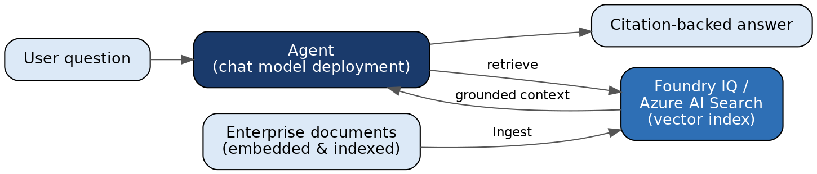
Figure 2 — The grounding workflow: documents are embedded and indexed; the agent retrieves relevant passages and answers with citations

5. Real-World Company Use Cases
Foundry is used by developers at more than 80,000 organizations, including a large share of the Fortune 500. The cases below are published Microsoft customer stories — each one maps to a workflow pattern you can reproduce with the building blocks covered in this course.

5.1 Heineken — “Hoppy,” a Multi-Agent Knowledge Platform
Heineken built a multi-agent platform called Hoppy on Azure AI Foundry to help employees across 70+ operating companies access data, documents, and internal tools in their own native language. An orchestrator agent routes each request to specialist agents for data, knowledge, and internal systems. Information lookups that used to take 10–15 minutes now take seconds, saving thousands of employee hours.
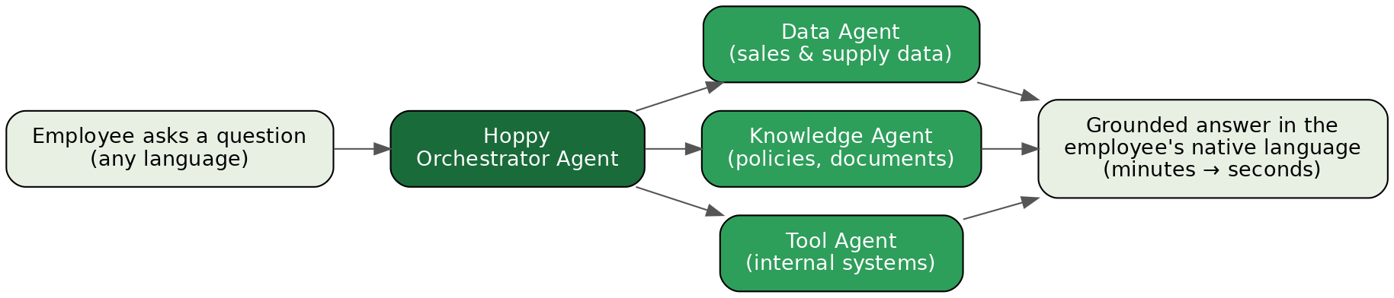
Figure 3 — Heineken's Hoppy: an orchestrator agent delegating to specialist agents
- Pattern to notice: multi-agent orchestration — one “front door” agent, several narrow specialist agents behind it. This is what Foundry's multi-agent SDKs are designed for.

5.2 Fujitsu — Sales Proposal Agent
Fujitsu used Azure AI Agent Service to automate sales proposal creation. The agent interprets a sales representative's request, pulls product specifications, pricing, and past proposals from multiple internal sources, and produces a current, precise draft. Fujitsu reports a 67% productivity boost, freeing sales teams to spend time on customer engagement instead of document assembly.
Figure 4 — Fujitsu's proposal agent: intent → multi-source retrieval → draft → human review
- Pattern to notice: retrieval + generation with a human in the loop. The agent drafts; the human approves and sends.

5.3 Gallagher — Insurance Claims Processing
Insurance broker Gallagher built its internal “Gallagher AI” platform on Microsoft Foundry, embedding AI directly into the daily work of roughly 60,000 employees. Agents extract key fields from claim documents, check them against policy coverage, and prepare summaries that flag exceptions for human adjusters — cutting claims review time by up to 90% and automating complex quote workflows.
Figure 5 — Gallagher's claims workflow: agents prepare and pre-check; humans keep the final decision
- Pattern to notice: document-heavy pipeline automation. AI handles extraction and checking at scale; the judgment call stays with a person.

5.4 KPMG — Employee-Built Agents at Scale
KPMG used Azure AI Foundry to let employees build their own agents and “micro-use cases” rather than waiting for a central IT team. One internal agent helps new hires find templates and historical project context, reducing follow-up calls by 20% and shortening time-to-productivity. The governance model from Section 2 is what makes this safe: central control at the resource level, freedom to build at the project level.

5.5 H&R Block — Real-Time Tax Filing Assistance
H&R Block built a solution on Azure AI Foundry and Azure OpenAI that answers filers' tax questions in real time and automates the extraction of key data from tax documents — reducing manual document handling while increasing accuracy and speeding up the overall preparation process. A textbook grounding workflow (Figure 2): the model's answers must come from trusted tax knowledge, not from the model's imagination.

5.6 More Examples in Brief
- Accenture — built a repeatable, secure generative-AI delivery platform on Foundry for orchestrating agent workflows with evaluation and observability; 75+ client use cases deployed, 16+ in full production across energy, healthcare, and financial services.
- Air India — customer-service virtual assistant on Foundry Agent Service that resolves service issues in natural language.
- ASOS — AI-powered virtual stylist that converses with shoppers and helps them discover new trends.

5.7 What These Cases Have in Common
Pattern | Example company | Foundry capability used
Multi-agent orchestration (one orchestrator, many specialists) | Heineken | Agent Service + multi-agent SDKs
Grounded Q&A over enterprise knowledge (RAG) | H&R Block, Heineken | Foundry IQ / Azure AI Search
Draft-and-review with a human in the loop | Fujitsu, Gallagher | Agent Service + tool connections
Governed self-service agent building | KPMG, Accenture | Resource/project split + RBAC

Sources: Microsoft Customer Stories — Fujitsu, KPMG, Gallagher, Accenture; Microsoft Azure Blog, “Azure AI Foundry: Your AI App and agent factory” and “From idea to impact.”

6. Connecting This Back to the RAG Project
Everything built in this course's hands-on project — a chat model, an embedding model, an Azure AI Search index, and an n8n-orchestrated agent — is a hand-built version of the same pattern the companies above run in production, and the pattern Foundry Agent Service and Foundry IQ now offer more directly inside the platform:
- The Azure AI Search vector store used in the RAG build is exactly the kind of “connected resource” described in the architecture section — governed separately from the Foundry resource, referenced through a connection
- Foundry IQ is Microsoft's productized version of the “upload documents → embed → retrieve → ground the answer” pipeline the course builds by hand — which is why understanding the manual version has lasting value even as platforms add shortcuts
- The n8n workflow plays the same role as Foundry's agent orchestration layer: it decides when to call the model, when to retrieve, and what to do with the result

6.1 A Note on Model Choice
Foundry's catalog has grown well past OpenAI-only. At the platform level you can use model families including GPT-5, GPT-4.1, Claude, Grok, Mistral, DeepSeek-R1, Phi-4, and Meta Llama. Whether a given n8n node supports a specific non-OpenAI Foundry model depends on that node's own integration — treat it as something to test, not a settled fact.

7. Review Questions
What is the risk, for a team building on Foundry, of Microsoft renaming or restructuring this platform for the third time in three years?
Suggested Answer: The primary risk is not technical—as the underlying Azure infrastructure remains stable—but organizational and operational. Frequent rebrands necessitate constant updates to internal training materials, documentation, and potentially onboarding workflows, which can create friction and confusion among development teams. The real-world mitigation is to focus team architecture on stable, provider-agnostic design patterns, such as using modular code that interacts with the platform's APIs, rather than relying too heavily on platform-specific UI workflows that may shift in future updates.
Given the Foundry resource/project split, who in a real company should hold Foundry Owner rights at the resource level vs. just Foundry User rights at the project level?
Suggested Answer: Governance and security best practices dictate that "Foundry Owner" roles should be limited to centralized IT, Platform Ops, or Security teams. These roles manage the "control plane"—billing, network boundaries, and global security policies—which must remain consistent across the organization. In contrast, "Foundry User" or project-level roles should be assigned to the product or business teams building the agents. This separation ensures that individual project teams have the autonomy to innovate within their project sandbox without the authority to inadvertently alter organization-wide governance, networking, or cost controls.
Heineken's Hoppy uses one orchestrator agent in front of several specialist agents. Why not build a single large agent that does everything?
Suggested Answer: A single "super-agent" is fundamentally more brittle and harder to govern than a system of specialist agents. Large, general-purpose models acting as a single agent often suffer from "instruction drift," where they may prioritize one task over another or hallucinate when handling diverse data types. By using an orchestrator-specialist pattern, teams can isolate failures, update specific specialist agents without disrupting the entire system, and maintain clearer evaluation benchmarks for each narrow task—ultimately leading to a more reliable, scalable, and maintainable enterprise application.
Gallagher automates up to 90% of claims review time but keeps a human adjuster on every decision. What kinds of tasks should stay human even when the agent is accurate?
Suggested Answer: Tasks involving legal liability, high ethical sensitivity, or nuanced interpersonal empathy must remain under human oversight regardless of agent accuracy. While an agent may be excellent at data extraction or compliance checks, a human is required for "judgment calls" where the outcome impacts a person's life or financial well-being, or where legal accountability is absolute. Keeping a "human in the loop" for final decisions acts as a critical safety mechanism that mitigates risk, provides an ethical buffer, and ensures that the system handles edge cases that do not conform to historical training patterns.
Would you rather use Foundry IQ's built-in knowledge grounding, or keep building your own Azure AI Search pipeline by hand as in this course? What would make you choose one over the other?
Suggested Answer: Choosing between managed services like Foundry IQ and custom RAG pipelines involves a trade-off between speed-to-market and control. Use Foundry IQ when your primary goal is rapid deployment, standardized performance, and minimal infrastructure maintenance; it is an excellent "turnkey" solution for general enterprise knowledge tasks. Conversely, build a custom pipeline when you require deep architectural control—such as specialized chunking strategies, multi-modal integration, or specific cost-optimization requirements—that managed services may not yet support. The decision should be driven by whether your application’s competitive advantage lies in the uniqueness of your retrieval and data-processing logic.

Appendix — Reference Links
- What is Microsoft Foundry? — learn.microsoft.com/azure/foundry/what-is-foundry
- Microsoft Foundry architecture — learn.microsoft.com/azure/foundry/concepts/architecture
- Navigate from Classic to the new experience — learn.microsoft.com/azure/foundry/how-to/navigate-from-classic
- Role-based access control for Microsoft Foundry — learn.microsoft.com/azure/foundry/concepts/rbac-foundry
- What's new in Microsoft Foundry — learn.microsoft.com/azure/foundry/whats-new-foundry
- Customer stories — microsoft.com/en/customers/story/21885-fujitsu-azure-ai-foundry; .../25357-kpmg-azure-ai-foundry; .../26313-gallagher-microsoft-foundry; .../23953-accenture-azure-ai-foundry
Note: URLs current as of mid-2026. Foundry documentation updates on a roughly 90-day cycle — check “What's new in Microsoft Foundry” for the latest terminology.

